Product Overview: SENSORSHLD1-EVK-101

ROHM Multi-Sensor Shield

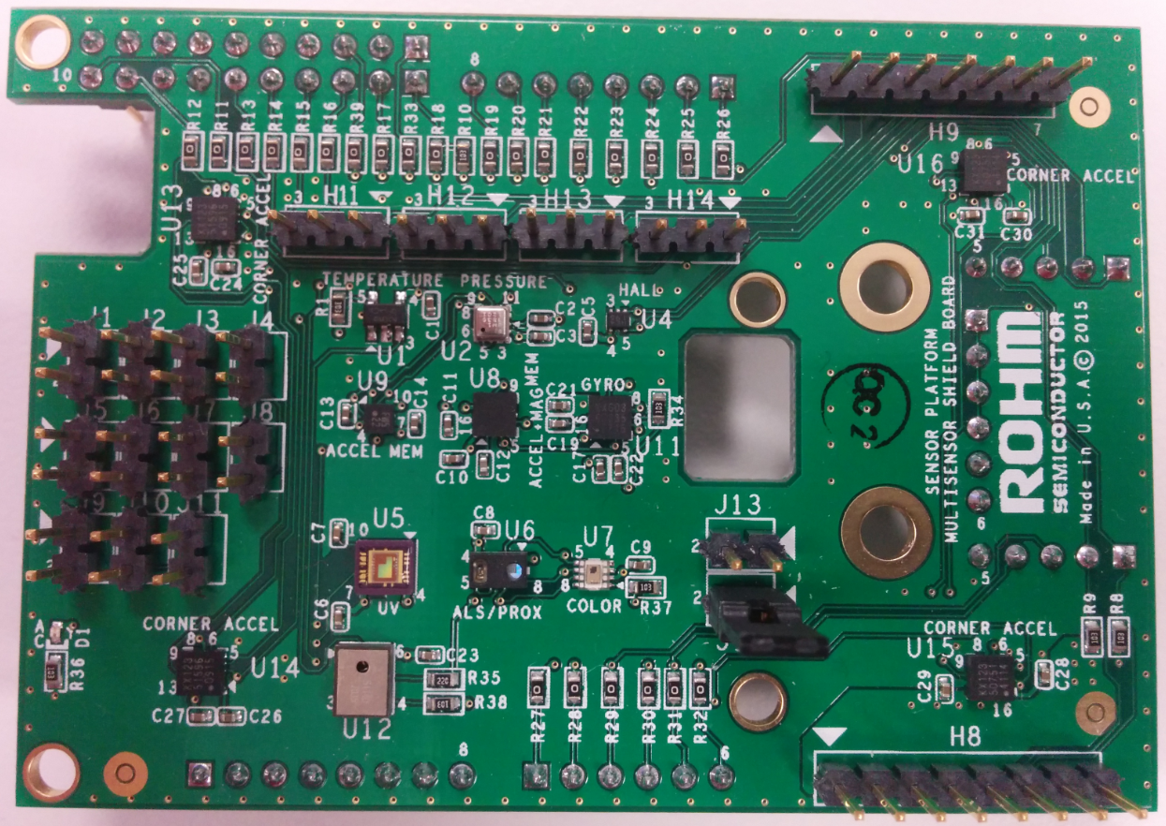

Above: Top view of ROHM SENSORSHLD0-EVK-101

25 September 2015, Revision A

# Introduction

The following document was written to provide a brief connection guide and general information about ROHM’s SENSORSHLD1-EVK-101. Supplementary information about this board can be found at the following repository link.

ROHM’s Multi-Sensor Shield GitHub Repository Page: <https://github.com/ROHMUSDC/ROHM_SensorPlatform_Multi-Sensor-Shield>

ROHM’s SENSORSHLD1-EVK-101 is a shield evaluation platform that connects all ROHM sensor products onto a single board. This shield uses standard Arduino shield interface pins; therefore can connect to any evaluation kit that has a shield interface header. The shield contains the following sensors:

* ROHM BDE0600G – Analog Temperature Sensor
* LAPIS ML8511 – Analog UV Sensor
* ROHM BU52011HFV – Hall Switch Sensor
* KIONIX KMX62 – Digital Accelerometer and Magnetometer
* ROHM BM1383GLV – Digital Barometric Pressure Sensor
* ROHM RPR-0521 – Digital Ambient Light Sensor and Proximity Sensor
* ROHM BH1745 – Digital Color Sensor
* KIONIX KX022 – Digital Accelerometer

***NOTE: As of 10-7-2015, ROHM is currently working on making revisions to the SENSORSHLD0-EVK-101 to SENSORSHLD1-EVK-101. This documentation DOES NOT provide all details about that board yet, but is a placeholder DS for that product once ready. If you have any immediate concerns about this topic, please feel free to let us know at*** [***engineering@rohmsemiconductor.com***](mailto:engineering@rohmsemiconductor.com)

# Key Differences between SHLD0 and SHLD1

* Removed Erroneous Jumpers
* Removed J5 to J11 and adjusted routing for J1 to J4
* Added ROHM BM1422GMV Magnetometer, 1.8V level shifter, and 1.8V LDO (for Magnetometer usage)

# General Board Specifications

For the specifications of the individual sensors on this shield board, please refer to the associated datasheet/application note that can be found on [www.rohm.com](http://www.rohm.com)

In general, this shield board will be powered by the V3.3 pin (Pin 4 of Header H4) on the shield board. Please only connect a maximum of 3.3V to this pin as it is tied to the VDD of the full system and some of the sensors onboard cannot tolerate voltages greater than 3.3V.

# Hardware Explanation Section



1. POWER ON LED: When the shield have 3.3V connected to the VCC Net, this LED will turn on
2. BDE0600G Temperature Sensor
3. BM1383GLV Pressure Sensor
4. BU52014HFV Hall Effect Switch Sensor
5. KX122 Accelerometer
6. KMX62 Accelerometer and Magnetometer Combo Sensor
7. KXG03 Gyroscope and Accelerometer Combo Sensor
8. ML8511 UV Sensor
9. RPR-0521 Combo Ambient Light Sensor and Proximity Sensor
10. BH1745 RGB Color Sensor
11. H4 – Standard Arduino Power Header
    1. On the shield board, this header is only connected to pins 4, 7 and 8. See section below for an explanation of the shield connector’s pin out
12. H5 – Standard Arduino AnalogIn Header
    1. See section below for an explanation of the shield connector’s pinout
13. H7 – Standard Arduino Digital Header 1
    1. See section below for an explanation of the shield connector’s pinout
14. H10 - Auxiliary header for Microphone interface
15. H6 – Standard Arduino Digital Header 2
    1. See section below for an explanation of the shield connector’s pinout
16. 0 Ohm Jumper Line for pins connected to H5
    1. 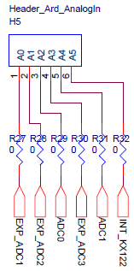
    2. The purpose of these headers are to depopulate pin connections on the shield if the user decides to use a pass through path or needs to adjust pin functionality depending on the needed pin configuration
17. 0 Ohm Jumper Line for pins connected to H6 and H7
    1. 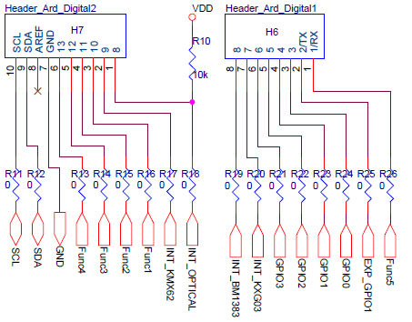
    2. The purpose of these headers are to depopulate pin connections on the shield if the user decides to use a pass through path or needs to adjust pin functionality depending on the needed pin configuration
18. H9 – Expansion Header for SPI devices
    1. 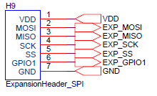
    2. This header is an expansion header to connect any additional SPI based sensors that you may want to use
19. H8 – Expansion Header for I2C devices
    1. 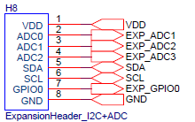
    2. This header is an expansion header to connect any additional I2C based sensors that you may want to use
20. Interface to the ROHM Sensor Platform Kit
    1. This is the interface onto the base board provided in ROHM’s sensor platform kit
    2. Please see the following repository for this Sensor Kit for additional Information
       1. <https://github.com/ROHMUSDC/ROHMSensorPlatformEVK>
21. J13 – Jumper Setting for KXG03 Gyroscope Sensor
    1. When Jumper is not used, the ADDR pin on the Gyro will be tied low, making the I2C address 0x4E
    2. When Jumper is used, the ADDR pin on the Gyro will be tied high, making the I2C address 0x4F
22. J12 – Jumper Setting for the BH1745 Color Sensor
    1. When Jumper is not used, the ADDR pin on the color sensor will be tied low, making the I2C address 0x38
    2. When Jumper is used, the ADDR pin on the color sensor will be tied high, making the I2C address 0x39
23. H11 – Function 1 Pin assignment
    1. 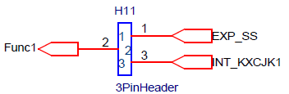
24. H12 – Function 2 Pin assignment
    1. 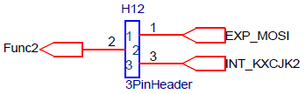
25. H13 – Function 3 Pin assignment
    1. 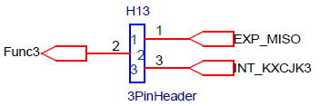
26. H14 – Function 4 Pin assignment
    1. 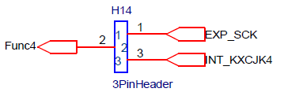
27. Do Not Use
    1. This was initially added to be used with the older sensor platform kit; however, this was deemed unnecessary for future revisions. This will be removed/revised for future revisions of this board.

# General Board Software Explanation

Software explanations will differ, depending on the application processor you plan to use. Therefore, please see this shield’s repository for platform guides for using this shield:

<https://github.com/ROHMUSDC/ROHM_SensorPlatform_Multi-Sensor-Shield>

…/ROHM_SensorPlatform_Multi-Sensor-Shield/Platform Code/